**MACHINE LEARNING BASED DIABETES PREDICTING SYSTEM**

By

Vishnupriyan K

B.E – CS

INTRODUCTION

Diabetes mellitus is chronic, a ceaseless ailment where it caused because of the high sugar level in the circulatory system. It is caused because of the inappropriate working of the pancreatic beta cells. It has an impact on different parts of the body which incorporates pancreas glitch, risk of heart ailments, hypertension, kidney disappointments, pancreatic issues, nerve harm, foot issues, visual unsettling influences, and other eye issues, waterfalls, and glaucoma and so on. There are different purposes behind reason like a way of life of a man, the absence of activity, sustenance propensities, heftiness, smoking, high cholesterol, high blood pressure etc. which fundamentally increment the risk of treating diabetes. It influences a wide range of ages, including youngsters to grown-up and matured people.

Pancreas is an organ situated in the midriff area. It has 2 fundamental capacities one endocrine capacity and exocrine capacity. The endocrine aides for assimilation and an exocrine segment in pancreas keep up the sugar level in the circulation system. The pancreas is related to numerous insufficiency and influences from different parts of the body. Whenever the glucose, or sugar level is high in the circulatory system, Beta cells of pancreas discharges the insulin to the circulation system, to assimilate the exorbitant sugar substance from the blood into liver, later it is changed over into a frame vitality. Similarly, at whatever point the glucose level is low, the creation of insulin is occupied and generating of glucagon by the alpha cells of the pancreas will be started to keep up the glucose level in the blood. The admission sugar in the body likewise assumes an imperative job in diabetes .

**Diabetes is classified into two types**

**TYPE 1:** A serious, incessant illness happens frequently happens in youngsters and grownups. Here pancreas totally stops the creation of the insulin. The individual assaulted by Type 1 is totally subject to insulin from outer drugs to control the sugar levels in the body. The DCCT (Diabetes Control and intricacies trail) assisted the individual through the rundown solutions with being taken after to keep away from the symptoms, extreme difficulties on different organs and live longer better life through the rules and sustenance propensities A dietary methodology was found through these rules.

**TYPE 2:** It is a class of perpetual; non-insulin subordinate sickness regularly happens in grownups. There are a few realities of the events of sort 2 are hereditary and metabolic components, family history, physical dormancy overweight, heftiness, undesirable eating regimen, smoking propensities expands the danger of diabetes .

In the proposed system the symptoms are taken as the input and the predict the type of diabetes and given related diet plan.

**OBJECTIVE**

In this project we must take the health features of the patients as an input and the trained machine learning model must predict the type of the patient and provide the diet plan for the respective type of diabetes.

Based on the attribute which is given as the input by the user, the respective type of diabetes is corresponding to the entered attribute would be given to the web page for the respective diet plane is displayed as the output to the user.

Here the scope of the project is that integration of clinical decision support with computer-based patient records could reduce medical errors, enhanced patient safety ,decrease unwanted practice variation, and improve patient outcome. This suggestion is promising as data modeling and analysis tools.

**LITERATURE**

Vijayakumar K et al proposed algorithm for the Prediction of diabetes develops a system which can perform early prediction of diabetes for a patient with a higher accuracy by using Random Forest algorithm in machine learning technique. The proposed model gives the best results for diabetic prediction and the result showed that the prediction system can predict the diabetes disease effectively, efficiently, and most importantly, instantly. Nonso Nnamoko et al. presented predicting diabetes onset: an ensemble supervised learning approach they used five widely used classifiers are employed for the ensembles and a meta-classifier is used to aggregate their outputs. The results are presented and compared with similar studies that used the same dataset within the literature. It is shown that by using the proposed method, diabetes onset prediction can be done with higher accuracy. Tejas N. Joshi et al. presented Diabetes Prediction Using Machine Learning Techniques aims to predict diabetes via three different supervised machine learning methods including: SVM, Logistic regression, ANN. This project proposes an effective technique for earlier detection of the diabetes disease. Deeraj Shetty et al. proposed diabetes disease prediction using data mining assemble Intelligent Diabetes Disease Prediction System that gives analysis of diabetes malady utilizing diabetes patient’s database. In this system, they propose the use of algorithms like Bayesian and KNN (K-Nearest Neighbour) to apply on diabetes patient’s database and analyze them by taking various attributes of diabetes for prediction of diabetes disease. Muhammad Azeem Sarwar et al. proposed study on prediction of diabetes using machine learning algorithms in healthcare they applied six different machine learning algorithms Performance and accuracy of the applied algorithms is discussed and compared. Comparison of the different machine learning techniques used in this study reveals which algorithm is best suited for prediction of diabetes. Diabetes Prediction is becoming the area of interest for researchers in order to train the program to identify the patient are diabetic or not by applying proper classifier on the dataset. Based on previous research work, it has been observed that the classification process is not much improved. Hence a system is required as Diabetes Prediction is important area in computers, to handle the issues identified based on previous research.

Decision tree is a classification technique. This technique is mostly use for prediction and classification. A tree comprises of paths, branches and leave nodes. Collection of branches is called path and represents the attribute value. Leaves represented Class value. Each path in decision tree symbolizes a rule which is used for classification or prediction. Decision tree divides the data into subsets or nodes. Root node represents the complete dataset. Tree pruning is preformed after tree is built completely. Pruning is started from the lead node. Being particular to J48 Decision tree classifier, it works on the following simple algorithm. While classify a new item, firstly it generates a decision tree grounded on the attribute values of the existing training data. So, each time it encounters a set of items (training set) it recognizes the attribute that distinguishes the numerous instances utmost clear. Among the likely values of this feature, if there is some value for which the data instances belonging inside its category has the similar value for the target variable, then we terminate that branch and ascribe to it the target value that we have obtained.

PROPOSED SYSTEM

A web application is created, where the patient health features such as age, blood sugar level before meals, blood sugar level after meals, average blood glucose level is entered and depending on entered parameters the machine learning model integrated to web application will predict the type of diabetes and according to the type of diabetes plan for the person will be displayed.

**ADVANTAGES OF PROPOSED SYSTEM**

1. Diabetes type can be predicted by using this method.

2. Diet plan are given to the patient.

3. Easy to use this method.

**HARDWARE REQUIREMENTS**

* System : Pentium IV 2.4 GHz
* Ram : 512 MB
* Processor : Pentium IV and Above
* Hard Disk : 40 GB

**SOFTWARE REQUIREMENTS**

* Windows 7 and Above
* Python 3.8 And Above

**SYSTEM ARCHITECTURE**

CREATE THE MODEL

TRAIN THE MODEL

PROVIDE THE INPUTS

MODEL WILL PREDICT THE TYPE OF DIABETES

TYPE 1 DIABETES

TYPE 2 DIABETES

NO DIABETES

DISPLAY THE “DIABETES FREE” MESSAGE

DISPLAY THE CORRESPONDING DIET PLAN

DISPLAY THE CORRESPONDING DIET PLAN

SYSTEM IMPLEMENTATION

LIST OF MODULES

1. Module importations.
2. Read the dataset.
3. Classifying the data.
4. Predicting the data.
5. Condition checking using else if.
6. Calling the function.

MODULE DESCRIPTION

MODULE IMPORTATIONS.

“Import Pywebio”

If you want to create a web application using python ,you can choose to use highly packages like flask,fastAPI. Pywebio is another python package that enables you to create simple web applications without prior knowledge of HTML and JavaScript.

“Import pandas as pd”

Panda’s package is very useful to us to read the tabular learn python library for handling tabular data.it can take in data from a wide range of sources such as CSV files.

“Import NumPy as np”

NumPy is a python library used for working with arrays .it also has functions for working in domain of linear algebra.

READ THE DATASET

“dataset=pd.read_csv('Diab.csv')”

This line of code is used to read the data set of Diab is the file name it stores the attribute of the diabetes type prediction of the terms. This line of code is used to read the data set as csv file format.

CLASSIFYING THE DATA

inputs=dataset.drop('outcome',axis='columns')

target=dataset.outcome

This is used to classifying the data attribute like such as Age,Blood_sugar_before_meals,Blood_sugar_after_meals,plasma_glucose_test_random,plasma_glucose_test_fasting,Average_blood_glucose_level,HbA1c it takes this kind of attribute and predict the type of diabetes.

PREDICTING THE DATA

out=model.predict([[Age,Blood_sugar_before_meals,Blood_sugar_after_meals,plasma_glucose_test_random,plasma_glucose_test_fasting,Average_blood_glucose_level,HbA1c]])

They predict the data using the decision tree classifier by taking this attribute and they get the value of each attribute and predict the type of diabetes and give the diet plan.

CONDITION CHECK USING ELSE IF

In the if condition they check the (out==1) if it is 1 the person affect by the type 1 diabetes and they provide the diet plan for the person.

elseif if the condition check (out==2) if the out is 2 the predict the person is affect by the type 2 diabetes and they provide the diet plan for the person.

Esle the person is free from the diabetes is give as the output.

CALLING THE FUNCTION

“diabetes_type()”

By using this line of code, it is used to call the function of diabetes_type and they will perform the operation.

CONCLUSION AND FUTURE ENHANCEMENT

CONCLUSION

Before implementation of the proposed system, it is difficult for a person to know whether he/she is affected by type 1 or type 2 diabetes or even diabetic free, because to know whether a person is affected by type 1 or type diabetes it is necessary to take HbA1C test and a glucose tolerance test. But now it is very simple for the person to know his/her type of diabetes using the proposed system within a minute and the diet plan to stay away from the further risk.

FUTURE ENHANCEMENT

In future, the proposed system can be extended as the mobile application which can be run in both android and in iOS, in which additional features can be included such as to receive the report to home is easy and the doctor get benefit of this.

RESULT

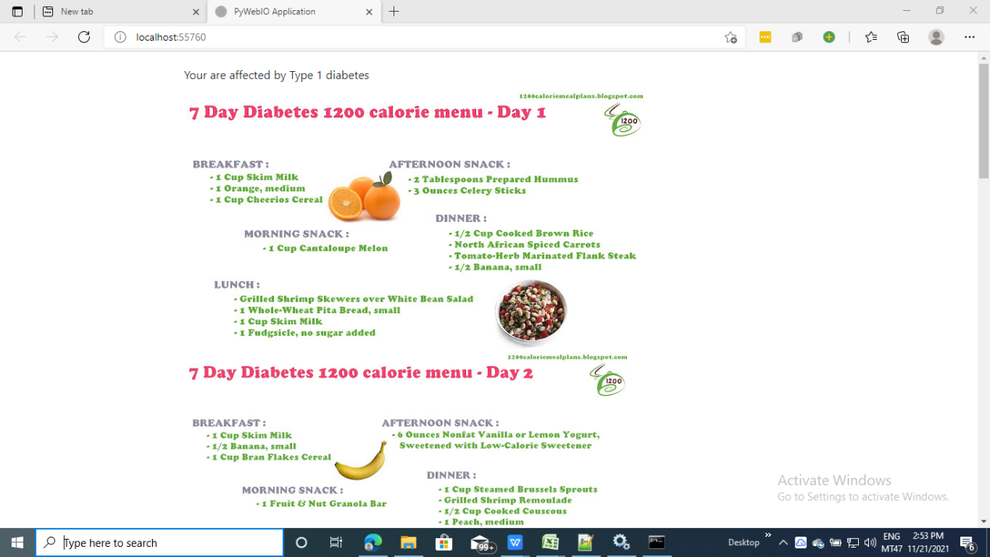

Diabetes type 1 diet plan

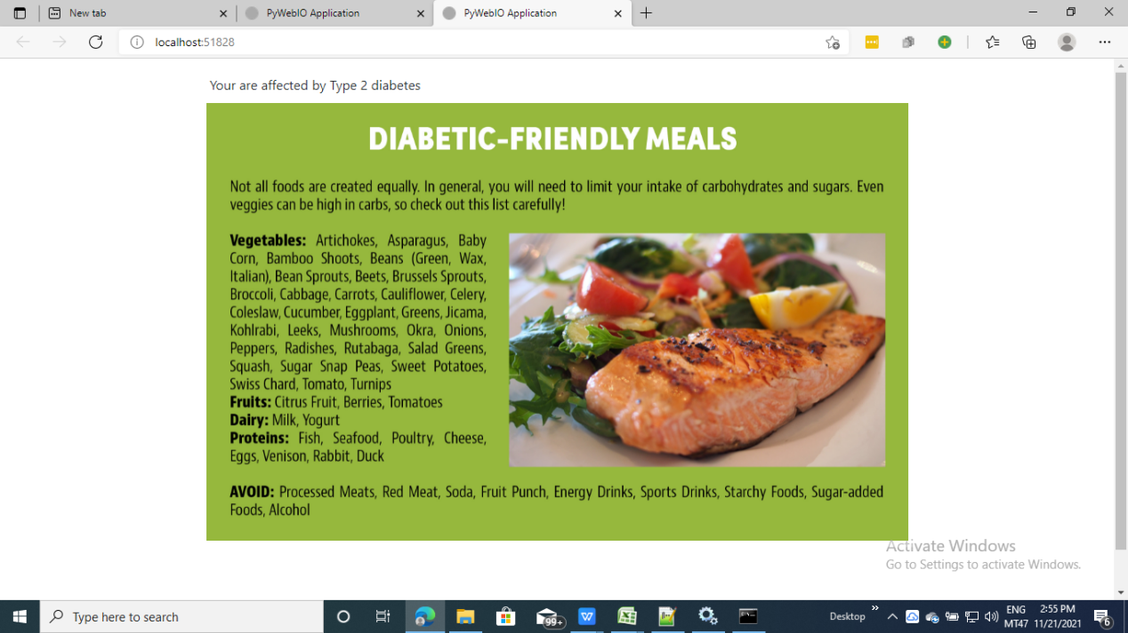

Diabetes type 2 diet plan



The person does not affect by the diabetes